VLSI Project: Elevator Control System

Part 4

Name: Prajwal Paul & Khoa Diep

ktd170030

psp170030

CE 6325

Instructor: Prof. Sechen

Date: 10/30/2023

**Inverter Layout Screenshot**

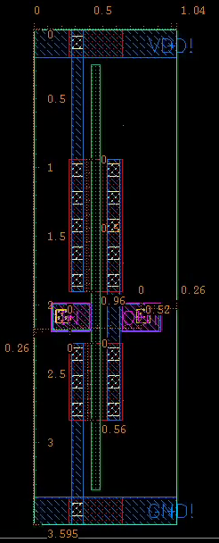

**Inverter Abstract View Screenshot**

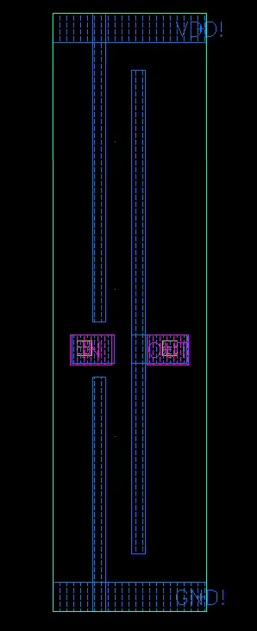

**Inverter Schematic Screenshot**

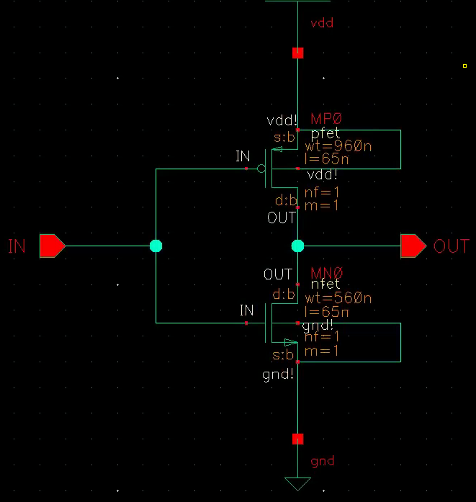

**Inverter Waveforms**

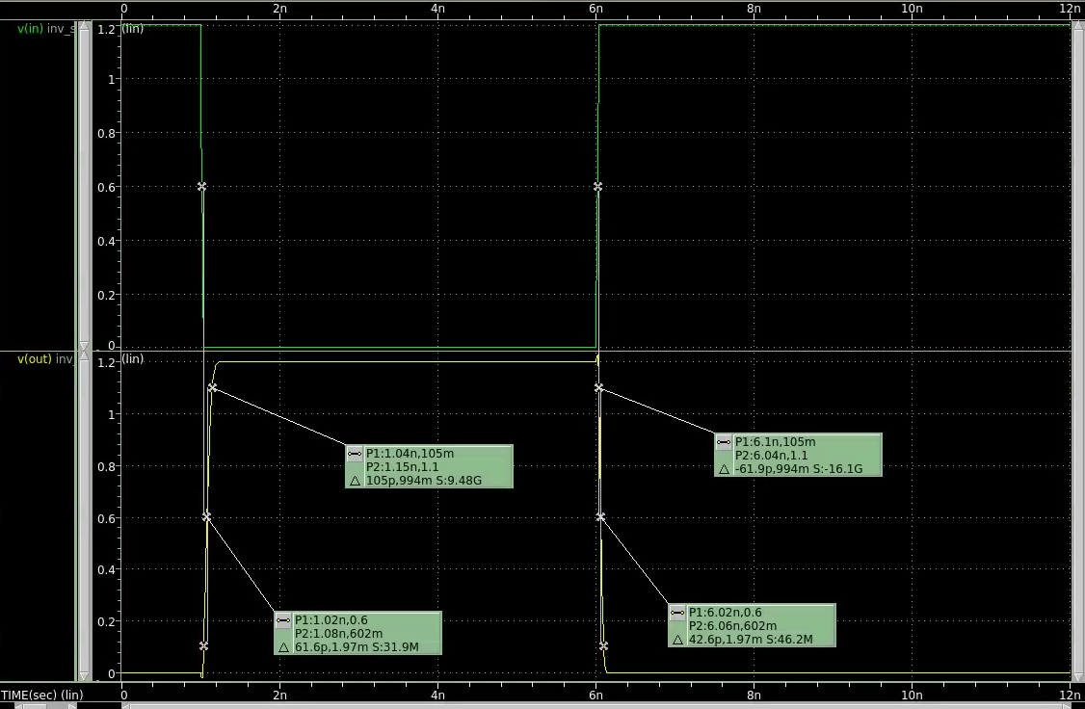

Rise Delay: 61.9 ps

Fall Delay: 42.6 ps

Output Rise Edge Rate: 105 ps

Output Fall Edge Rate: 61.9 ps

**Nand2 Layout Screenshot**

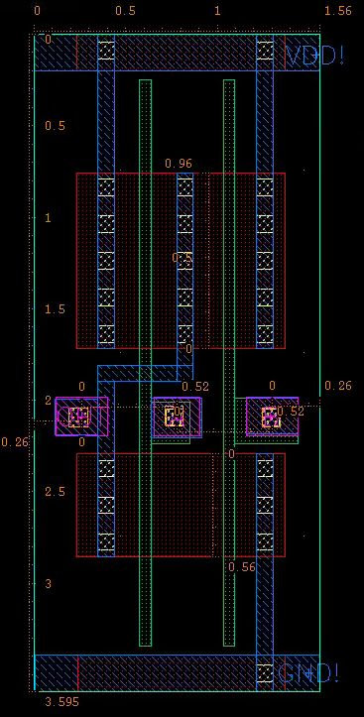

**Nand2 Abstract View Screenshot**

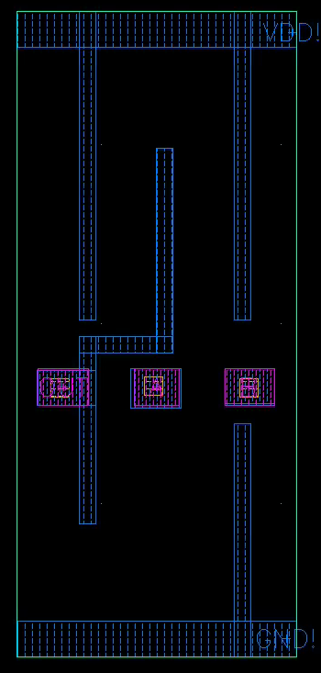

**Nand2 Schematic Screenshot**

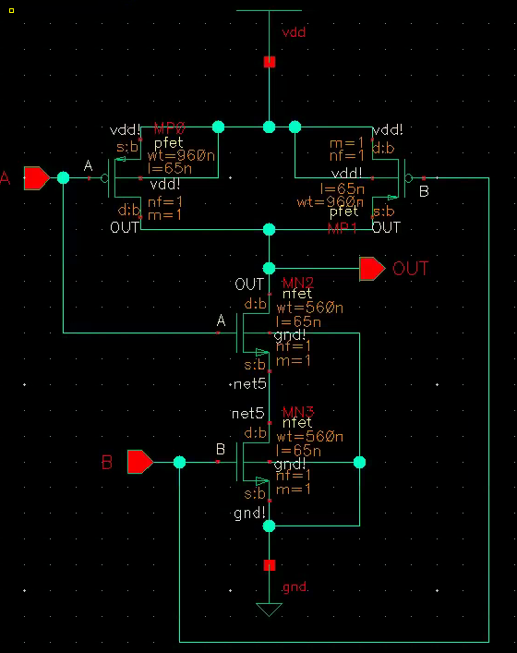

**Nand2 Waveforms**

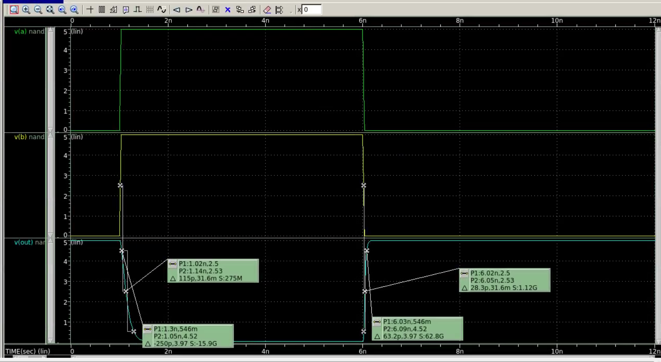

Rise Delay: 28.3 ps

Fall Delay: 115 ps

Output Rise Edge Rate: 63.2 ps

Output Fall Edge Rate: 250 ps

**Nand3 Layout Screenshot**

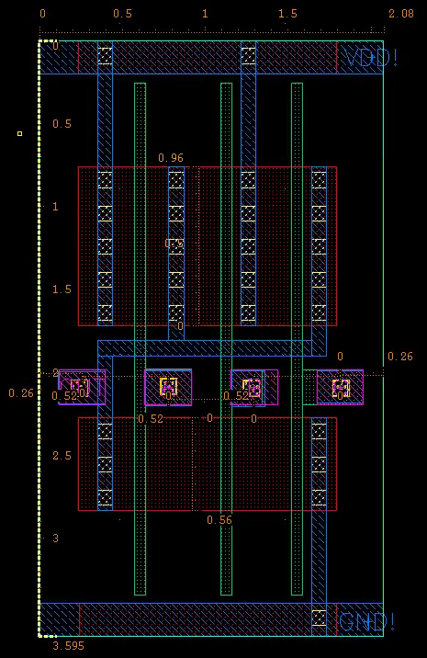

**Nand3 Abstract View Screenshot**

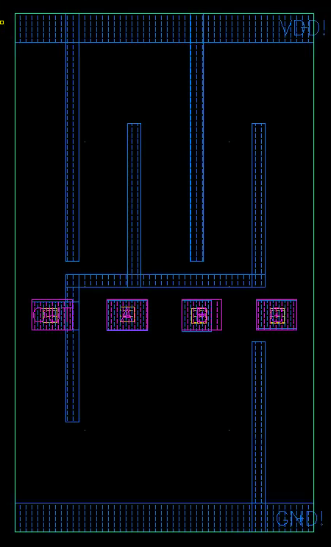

**Nand3 Schematic Screenshot**

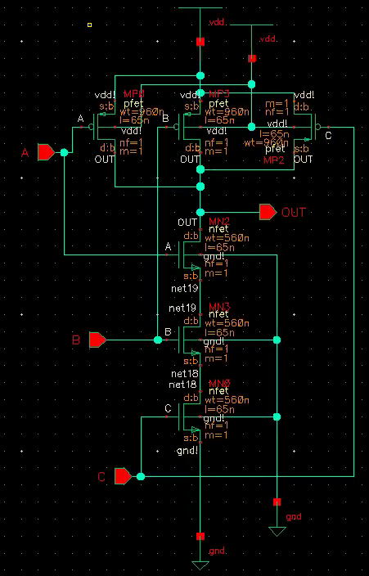

**Nand3 Waveforms**

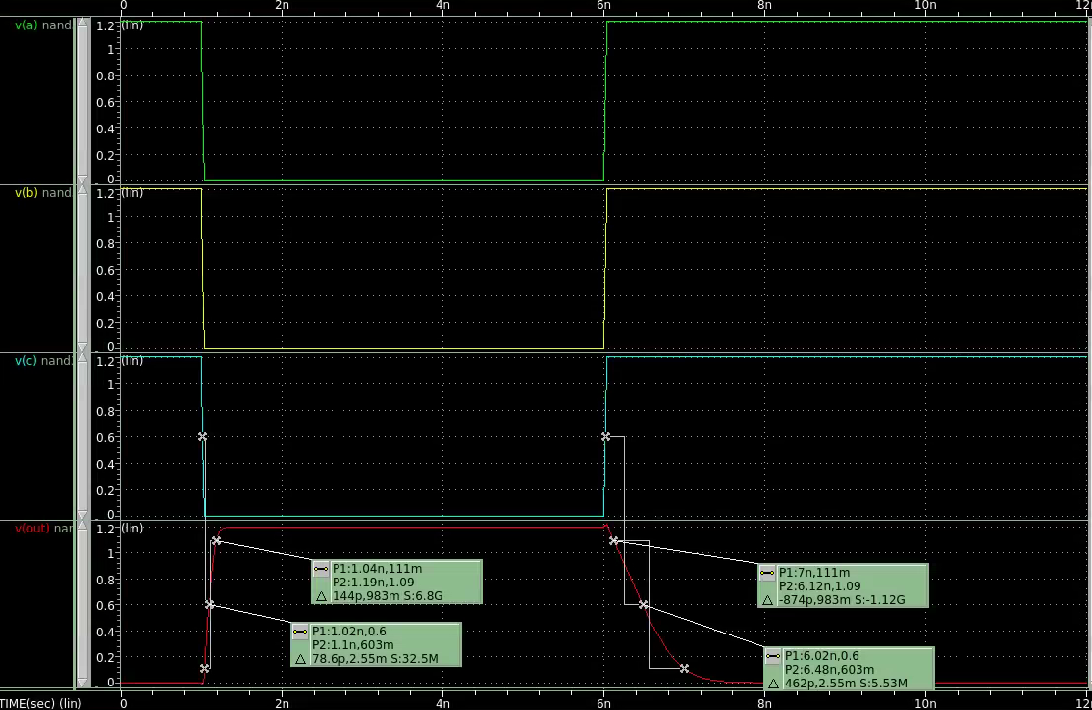

Rise Delay: 78.6 ps

Fall Delay: 462 ps

Output Rise Edge Rate: 144 ps

Output Fall Edge Rate: 874 ps

**Xor2 Layout Screenshot**

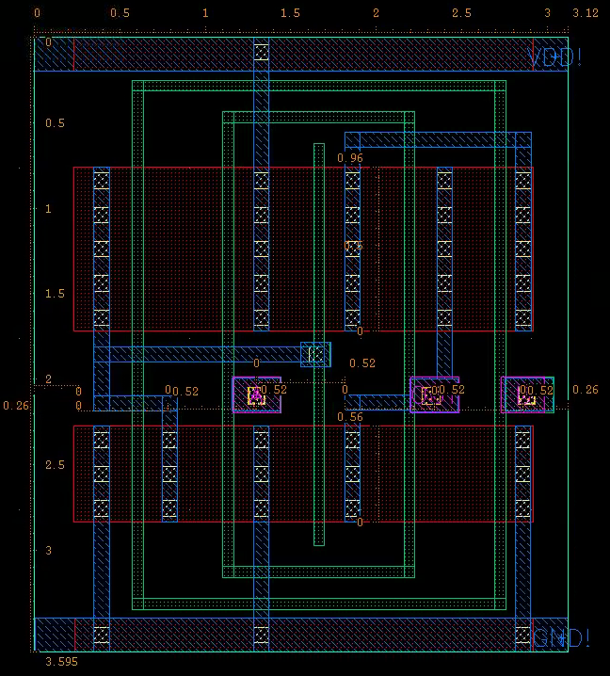

**Xor2 Abstract View Screenshot**

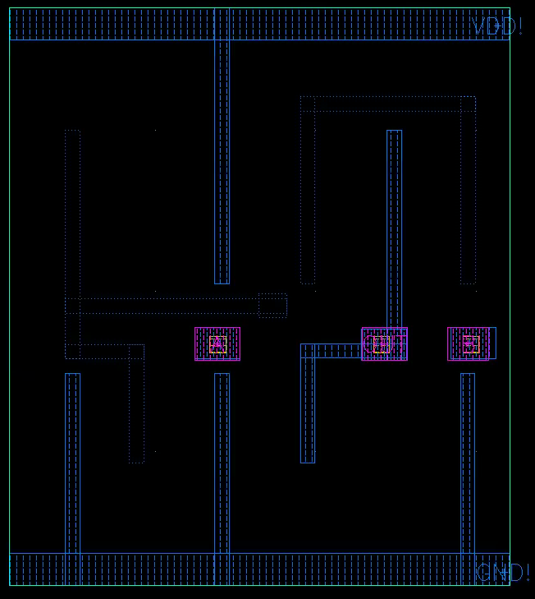

**Xor2 Schematic Screenshot**

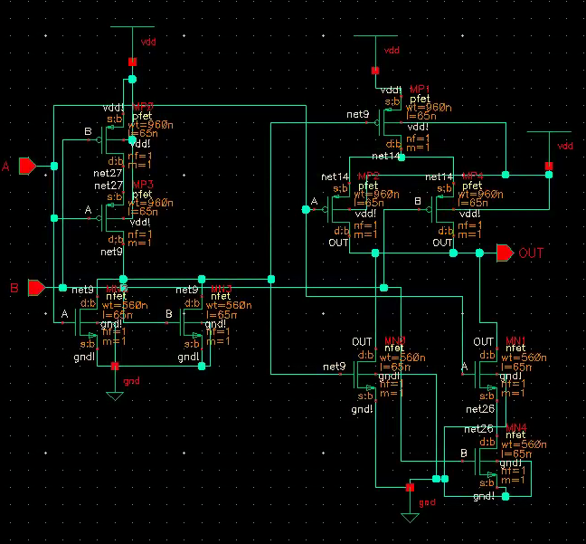

**Xor2 Waveforms**

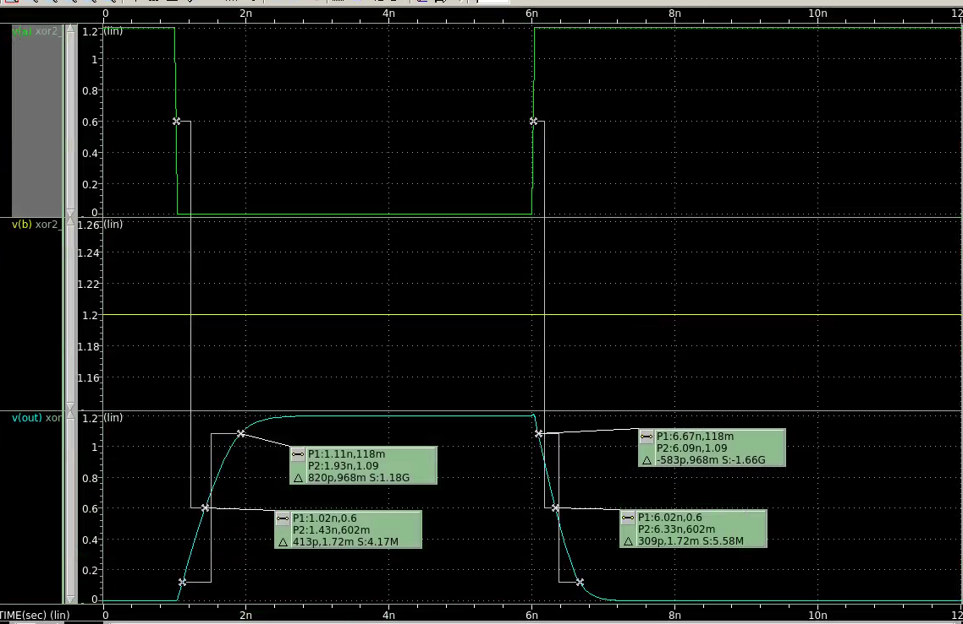

Rise Delay: 413 ps

Fall Delay: 309 ps

Output Rise Edge Rate: 820 ps

Output Fall Edge Rate: 583 ps

**Nor2 Layout Screenshot**

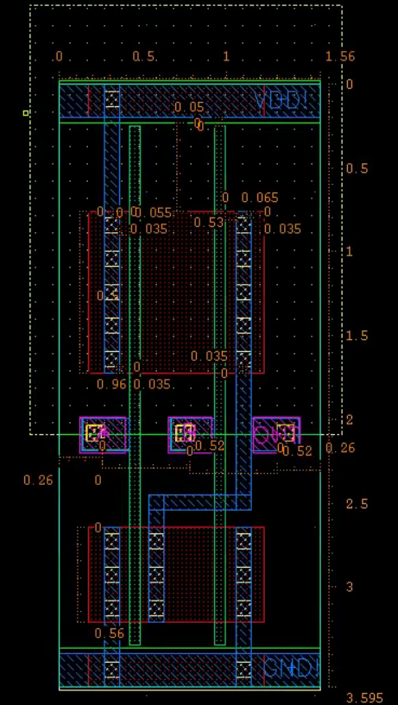

**Nor2 Abstract View Screenshot**

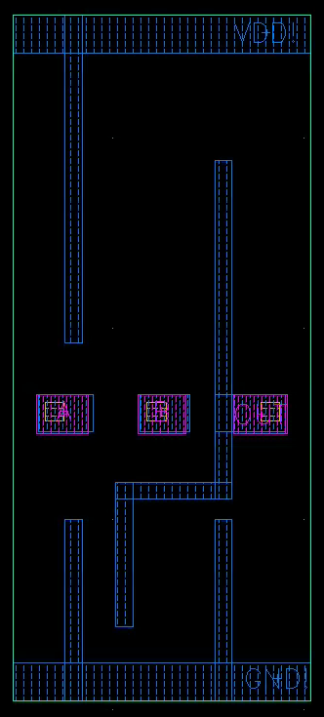

**Nor2 Schematic Screenshot**

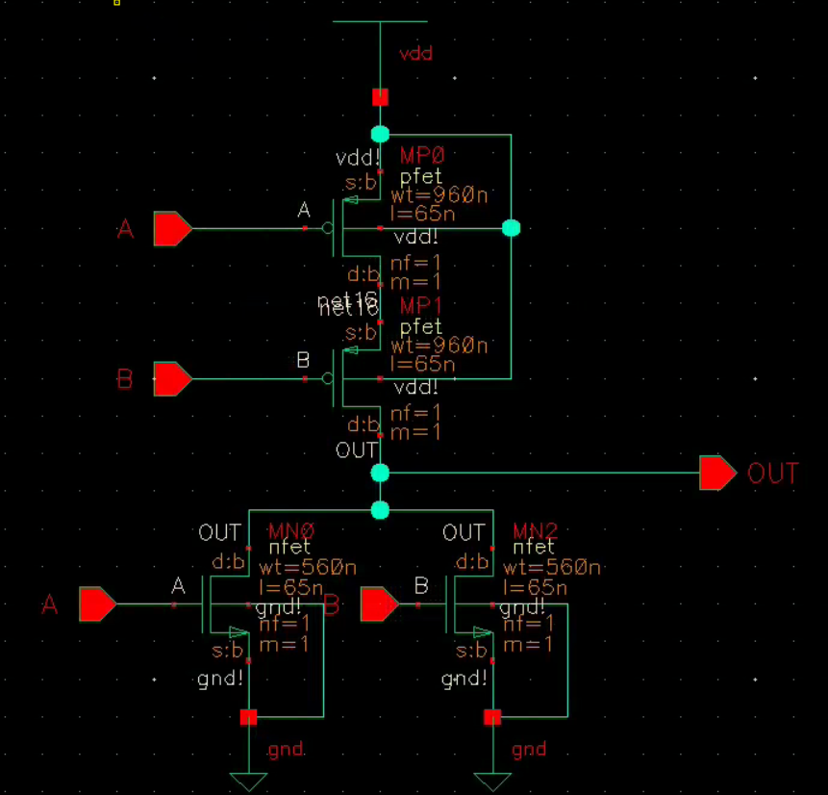

**Nor2 Waveforms**

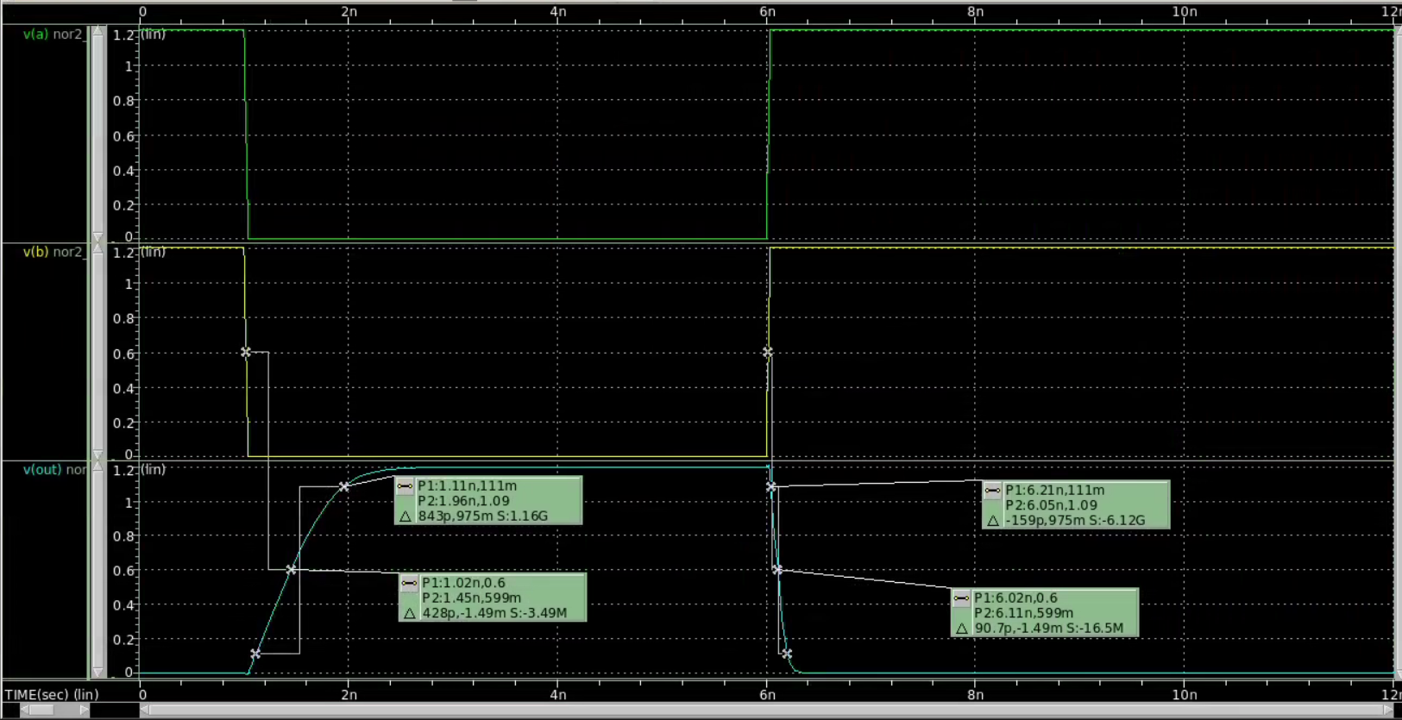

Rise Delay: 428 ps

Fall Delay: 90.7 ps

Output Rise Edge Rate: 843 ps

Output Fall Edge Rate: 159 ps

**Nor3 Layout Screenshot**

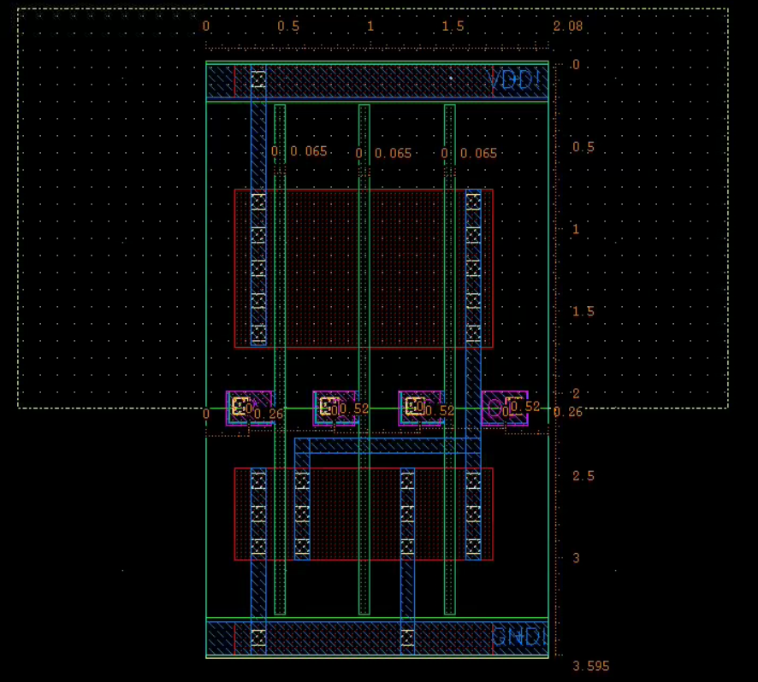

**Nor3 Abstract View Screenshot**

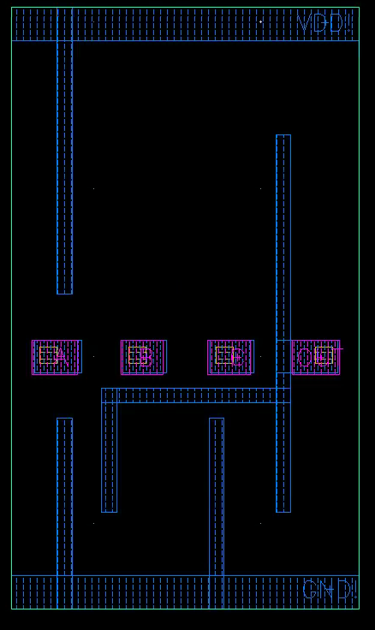

**Nor3 Schematic Screenshot**

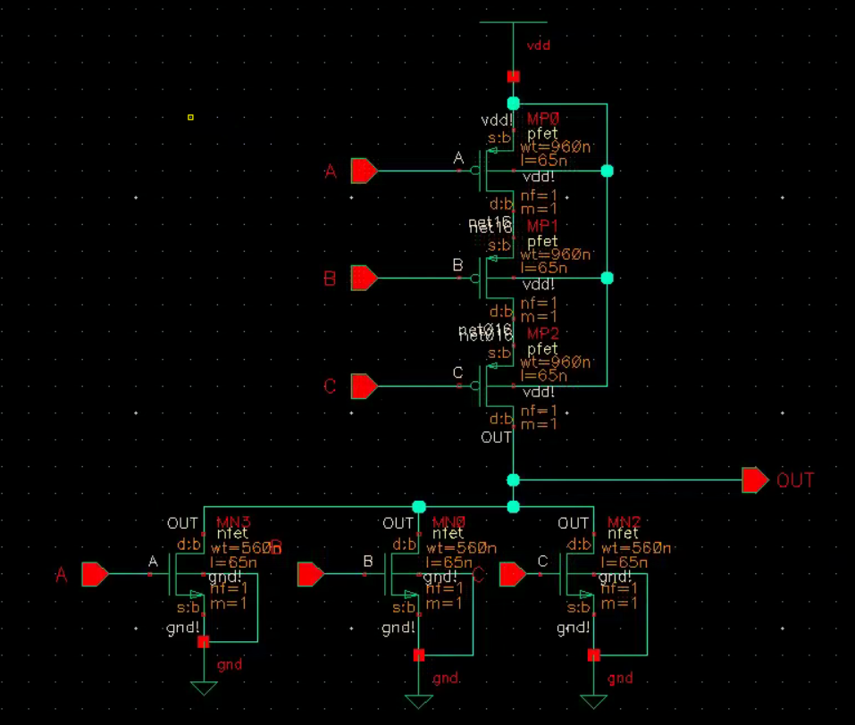

**Nor3 Waveforms**

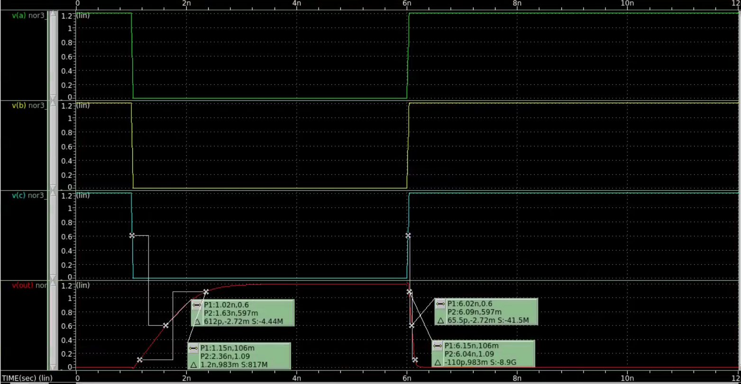

Rise Delay: 612 ps

Fall Delay: 65.5 ps

Output Rise Edge Rate: 1.2 ns

Output Fall Edge Rate: 110 ps

**AOI22 Layout Screenshot**

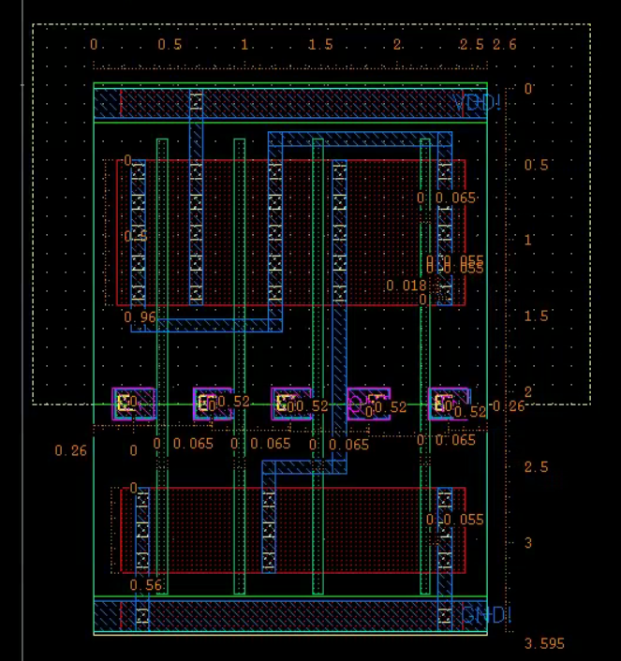

**AOI22 Abstract View Screenshot**

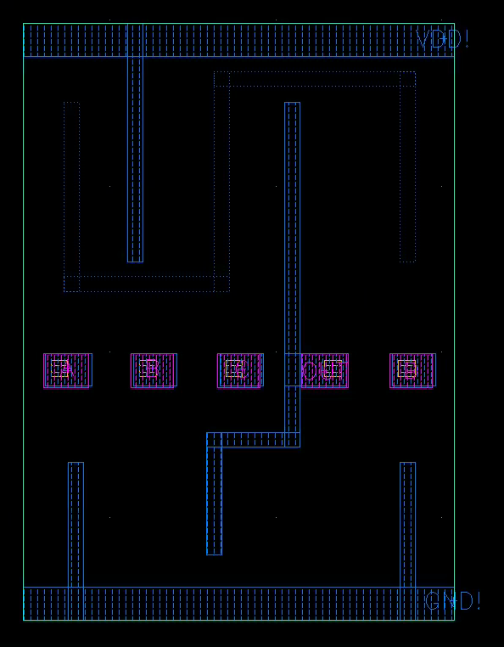

**AOI22 Schematic Screenshot**

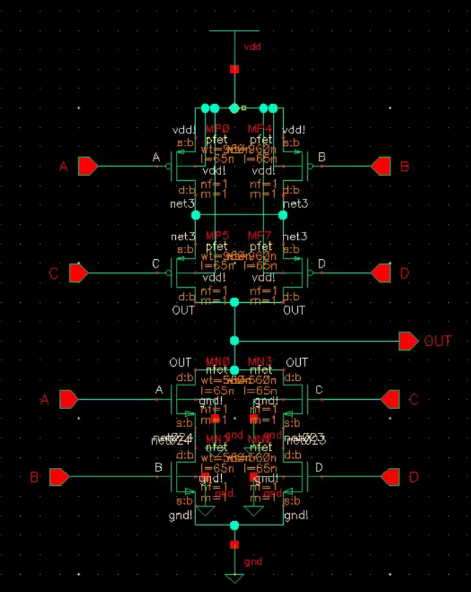

**AOI22 Waveforms**

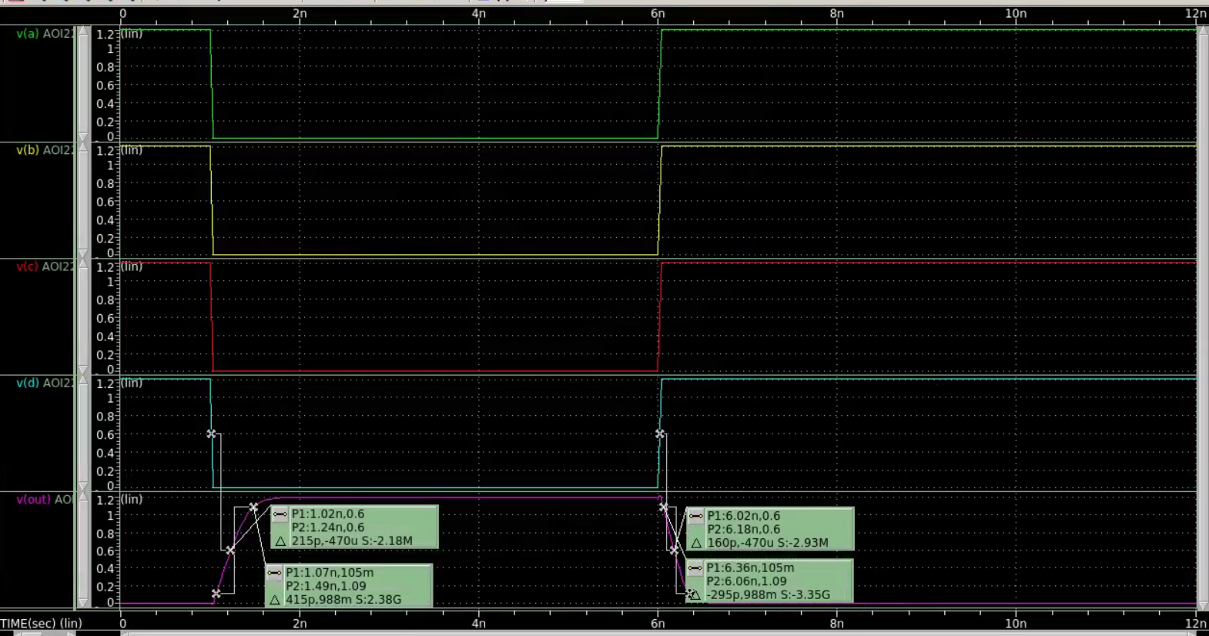

Rise Delay: 215 ps

Fall Delay: 160 ps

Output Rise Edge Rate: 415 ps

Output Fall Edge Rate: 295 ps

**OAI12 Layout Screenshot**

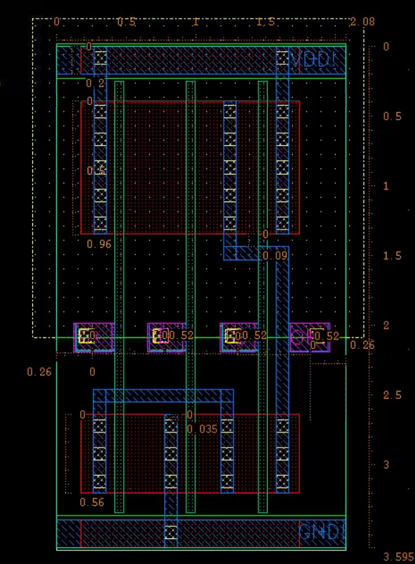

**OAI12 Abstract View Screenshot**

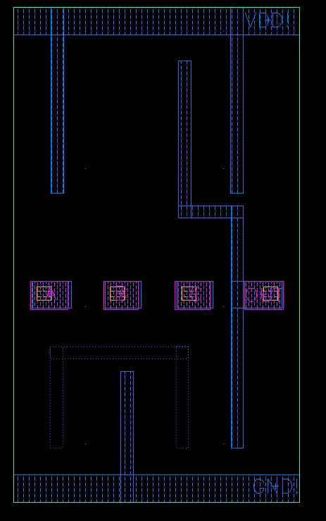

**OAI12 Schematic Screenshot**

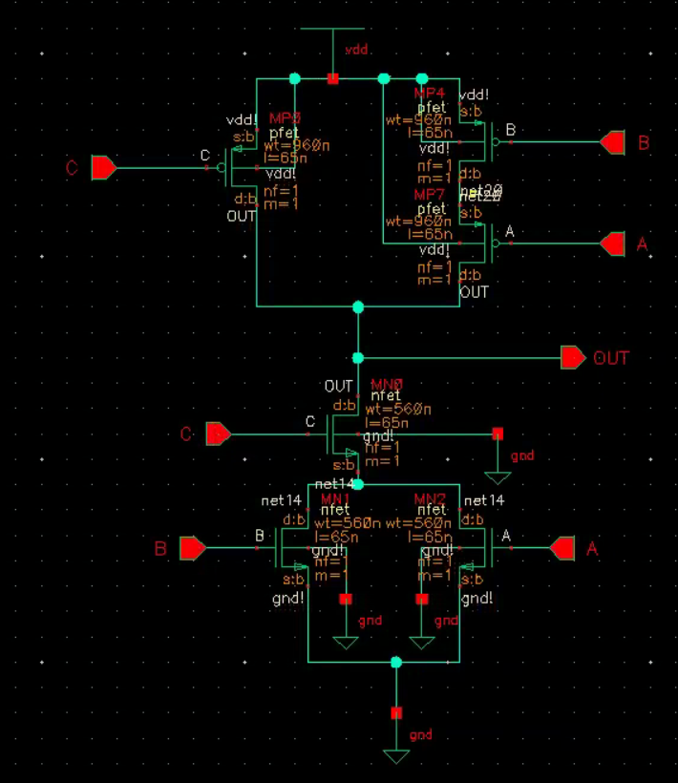

**OAI12 Waveforms**

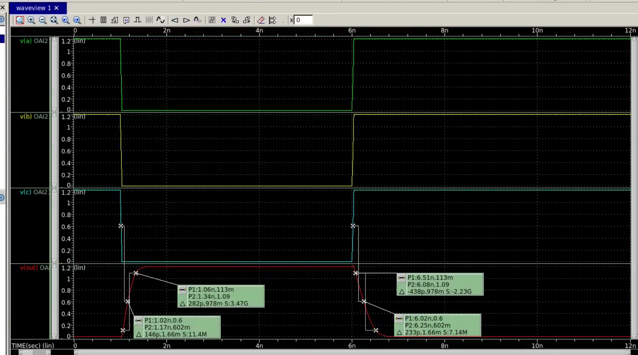

Rise Delay: 146 ps

Fall Delay: 233 ps

Output Rise Edge Rate: 282 ps

Output Fall Edge Rate: 438 ps

**All Gates Layout Screenshot**

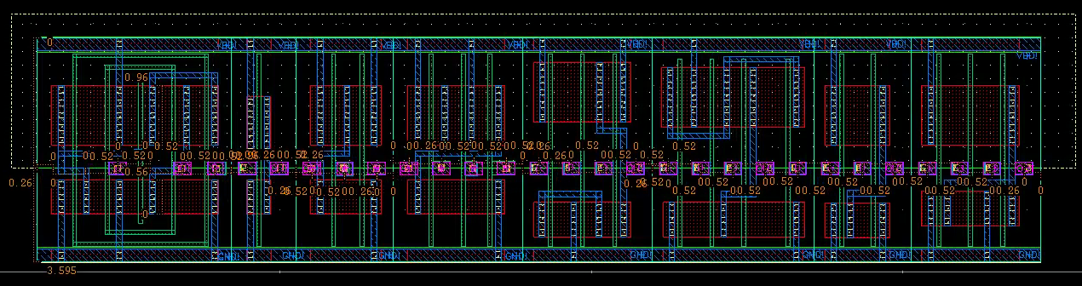

**All Gates DRC Screenshot**

